CLOUD COMPUTING
LAB 13



Submitted To:
Engr. Shoaib

Submitted By:
Komal Kashif
BSE V-A
2023-BSE-031

Task 1 — Create IAM Group and Output Details
task1_project_directory.png
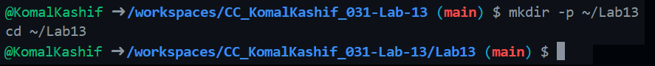
task1_file_created.png
task1_main_tf.png
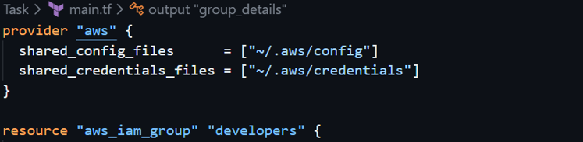
task1_terraform_init.png
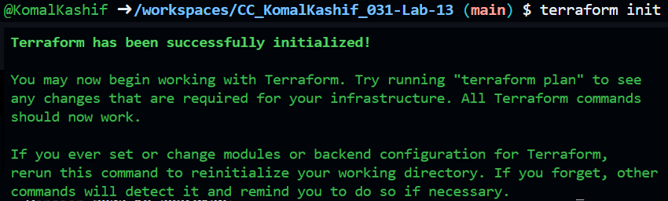
task1_terraform_apply.png
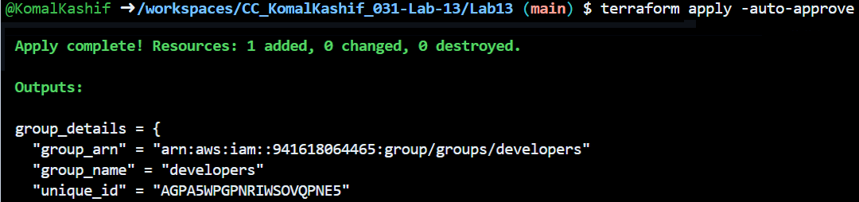
task1_terraform_output.png
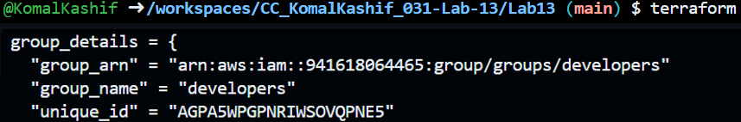
task1_aws_console_group.png
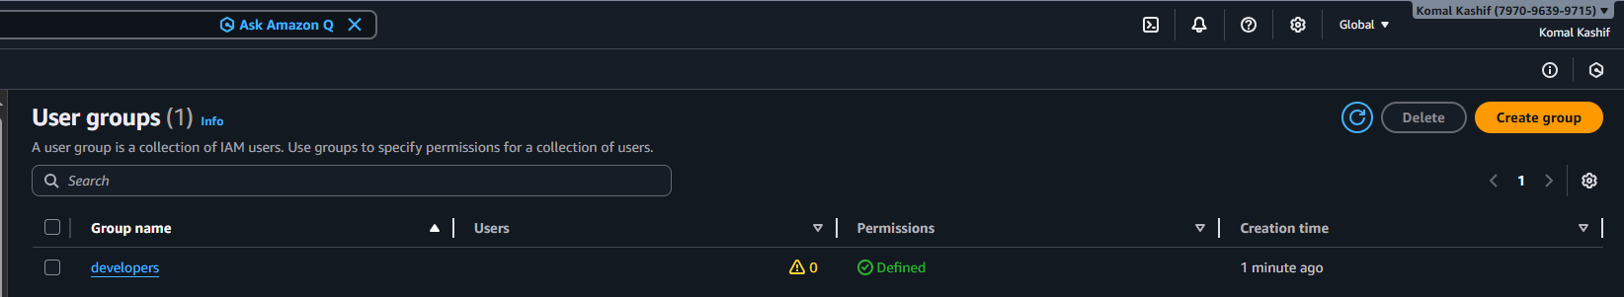
Task 2 — Create IAM User with Group Membership
task2_main_tf_user.png
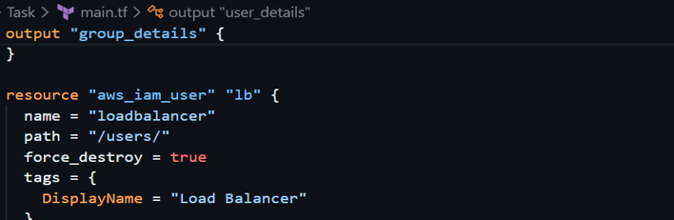
task2_terraform_apply.png
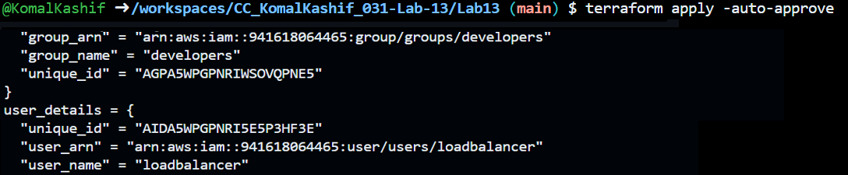
task2_terraform_output.png
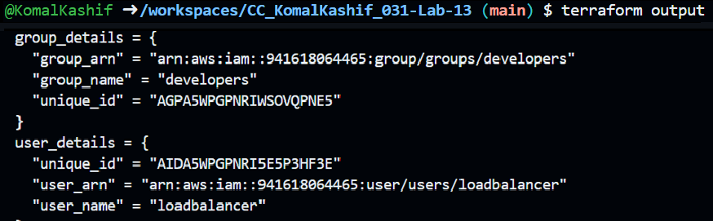
task2_aws_console_user.png
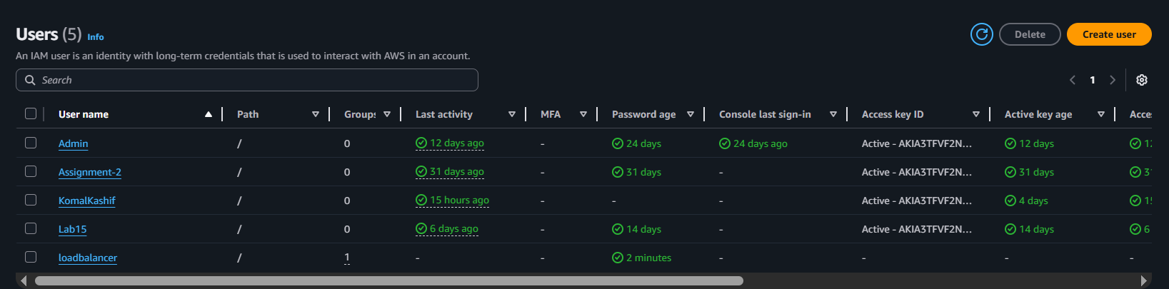
task2_aws_console_user_groups.png
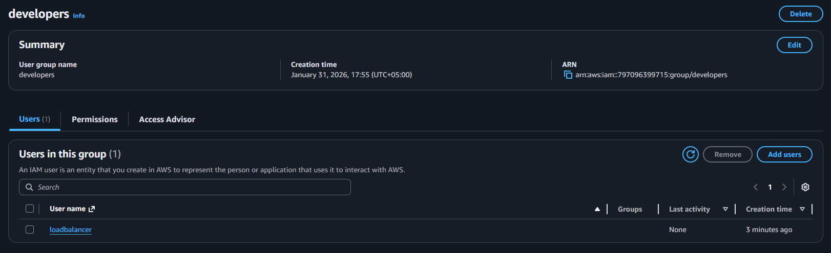
Task 3 — Attach Policies to IAM Group
task3_main_tf_policies.png
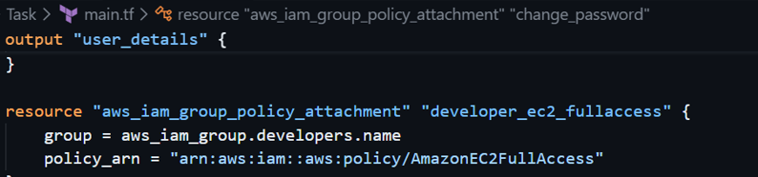
task3_terraform_apply.png
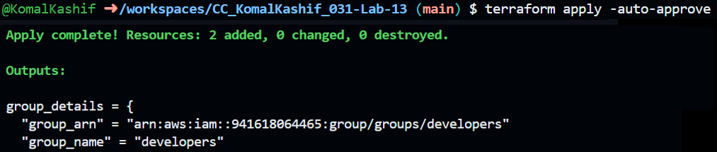
task3_aws_console_policies.png
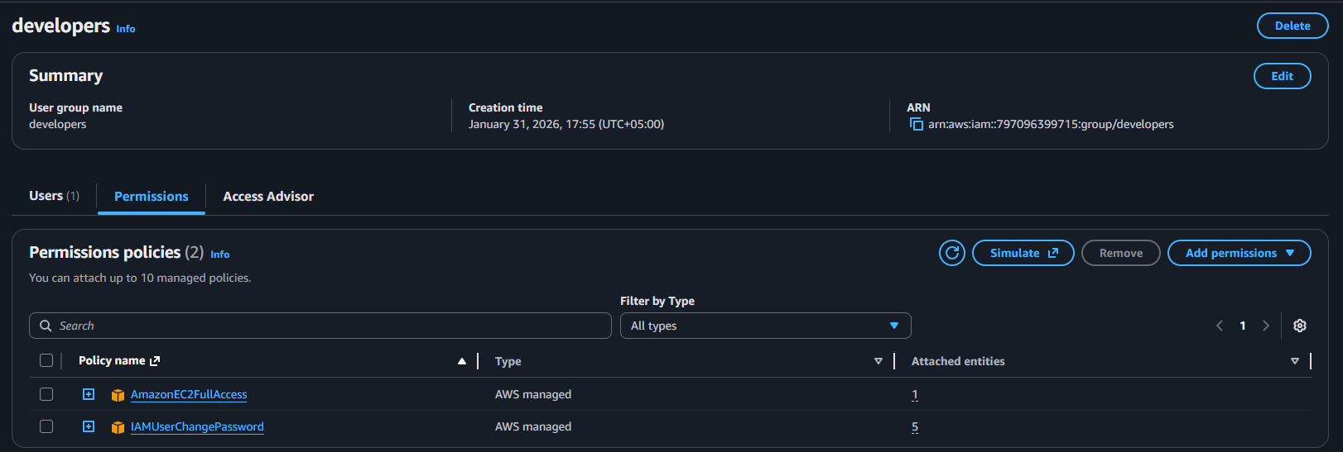

Task 4 — Create Login Profile for IAM User
task4_variables_tf.png
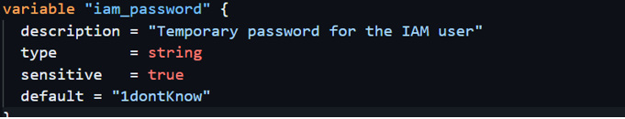
task4_create_login_script.png
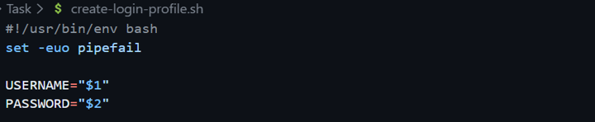
task4_chmod_script.png

task4_main_tf_login_profile.png
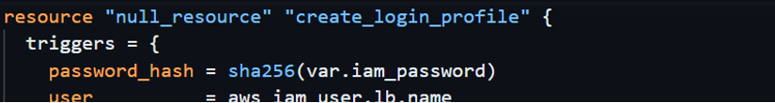
task4_terraform_apply.png
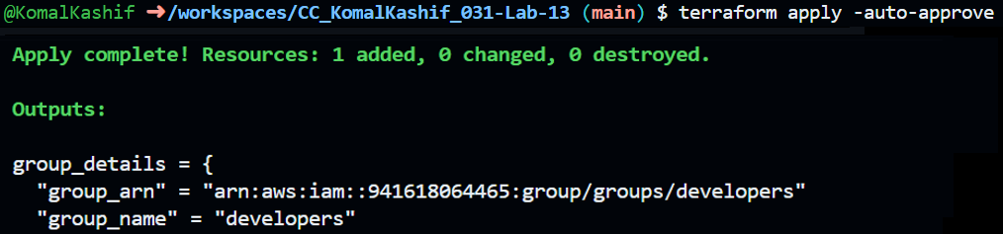
task4_aws_cli_verify.png
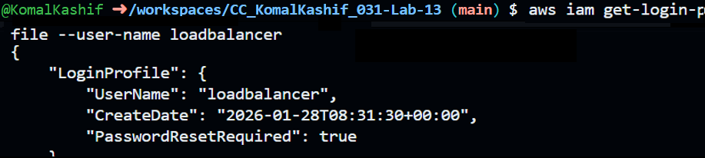
task4_aws_console_login.png
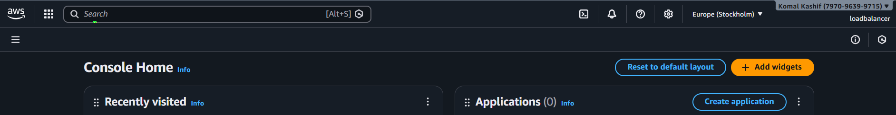

Task 5 — Generate Access Keys for IAM User
task5_main_tf_access_keys.png
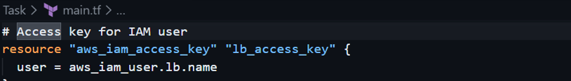
task5_terraform_apply.png

task5_terraform_output.png
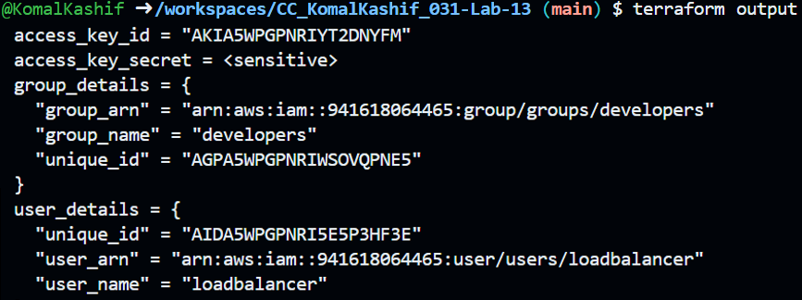
task5_tfstate_secret.png
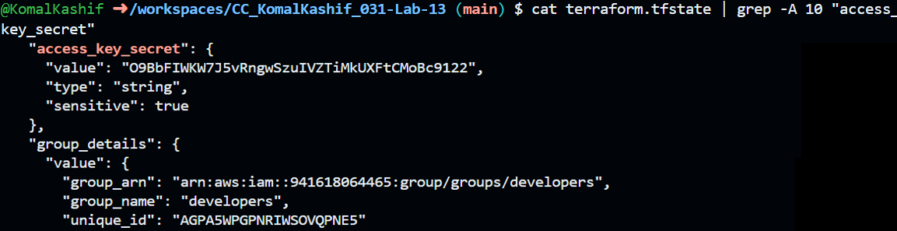
Task 6 — Implement Terraform Remote State with S3
task6_main_tf_backend.png
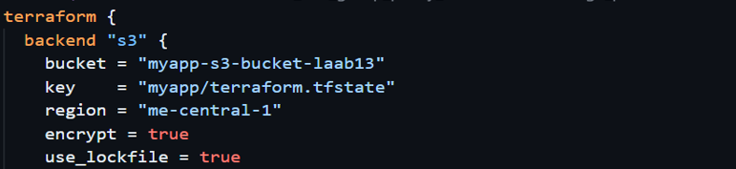
task6_terraform_init_migrate.png
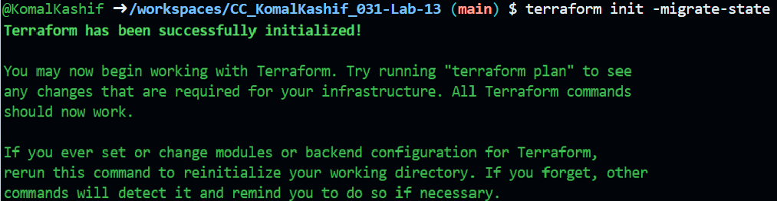
task6_terraform_apply.png
task6_local_state_backup.png
task6_terraform_destroy.png
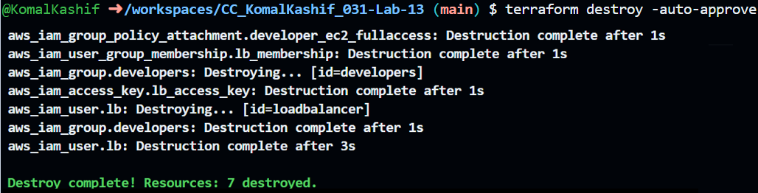
Task 7 — Create Multiple Users from CSV File
task7_locals_tf.png
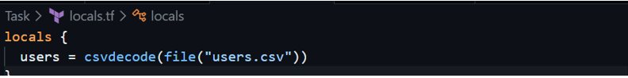
task7_users_csv.png
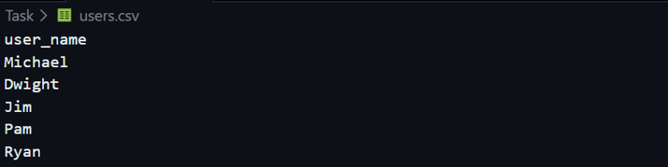
task7_main_tf_multiple_users.png
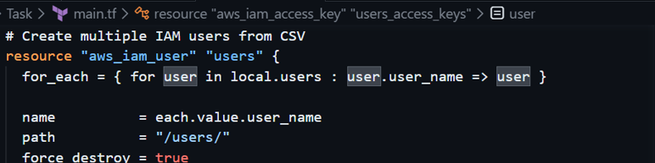
task7_terraform_init.png
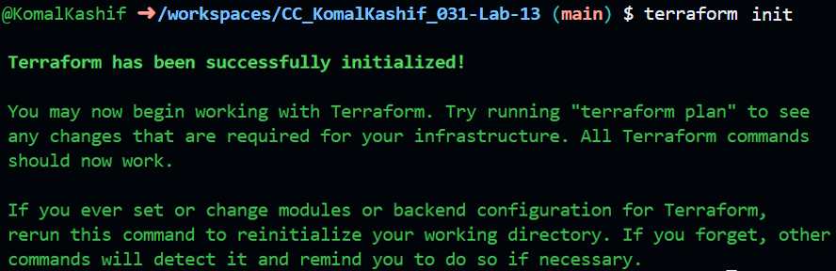
task7_terraform_apply.png
Cleanup:
cleanup_destroy_complete.png
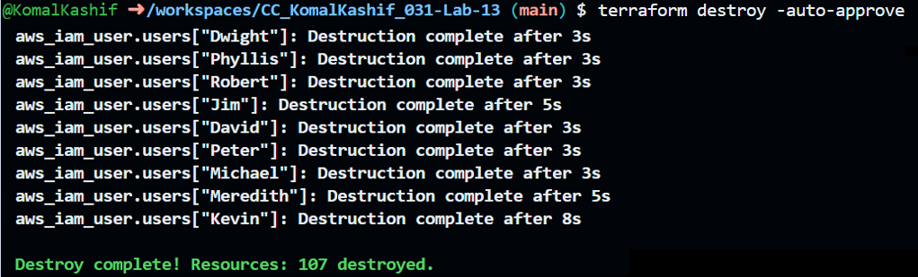
cleanup_aws_console_users_deleted.png
These are just the previous users which are left.
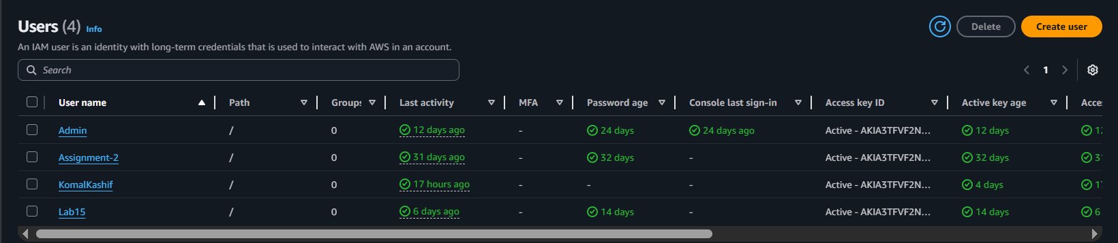
cleanup_aws_console_group_deleted.png
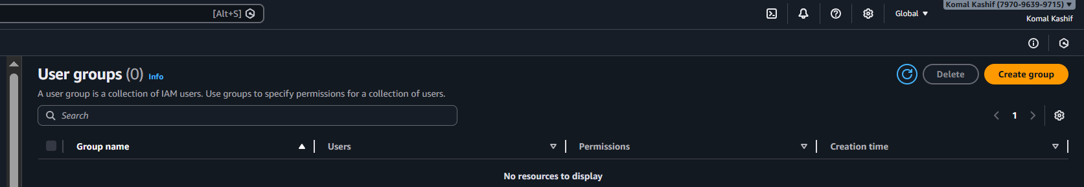
cleanup_final_files.png
